Consultation on proposed new review process for occupancy in supported housing – the findings

June 2020

Mike Walker, Hanif Patel and Melissa Sherliker

June 2020

For further information on the work of Business Intelligence please contact us at
Business Intelligence
Lancashire County Council
County Hall
Preston
PR1 8XJ
Tel: 0808 1443536
www.lancashire.gov.uk/lancashire-insight

Contents

1. Introduction 2

1.1 The proposal 2

2. Methodology 3

2.1 Limitations 3

3. Findings 4

3.1 Proposed approach for reviewing supported housing households. 4

3.2 People who completed the survey 12

Appendix 1 – respondent profile 13

Introduction
This report summarises the response to Lancashire County Council's proposal
to introduce a new review process for occupancy in supported housing households for people with care and support needs.

  - The proposal

Summary of the proposed new review process for Supported housing

The county council would review each Supported housing household vacancy on a case-by-case basis as appropriate.

Each review would follow a standard format and involve the following, where applicable:

Suitability
Does the household meet or can it be adapted to meet the needs of all tenants?

Affordability
Is it affordable for tenants to live in the household? Is it affordable for the county council or provider to deliver a Supported housing service in the household?

Occupancy
What are the prospects of maximising occupancy in the household?

Options
If required, is suitable alternative accommodation available?

Impact
What will it mean to tenants if the household was to close?

Responsibilities
Are there any contractual obligations for the household, the county council or providers?

Full details of the proposed new review process can be found here.

- Methodology

A public consultation was carried out to get feedback on the proposed new review process. Current residents and their relatives or representatives, staff, the public and providers were invited to provide their views via both paper and online self completion questionnaire. The consultation was on the Have your Say webpage and also accessible via the 10 local self-advocacy network meetings routinely held across Lancashire.

The consultation ran from 30 January 2020 to 25 March 2020, however responses were accepted until 8 June 2020.

A total of 27 responses were received.

Limitations
The findings presented in this report cannot be assumed to be fully representative of the views of all residents of Lancashire nor all users and stakeholders of the Supported housing service They should only be taken as reflecting the views of people who were made aware of the consultation and who, given the opportunity, felt compelled to respond.

The total number of completed questionnaires received for the consultation was 27, even though the consultation remained open until June 2020. The findings provided must be treated with caution for this reason also due to the small number of respondents.

- Findings

The following results are based on 27 responses to the online questionnaire.

3.1 Proposed approach for reviewing supported housing households.

Respondents were asked if they agreed or disagreed with the new approach for reviewing supported housing households.

- Over half of respondents disagreed with proposed new approach for reviewing Supported housing households, with just under half strongly disagreeing
- two out of five respondents agree with proposal

- Do you agree with the proposed changes?

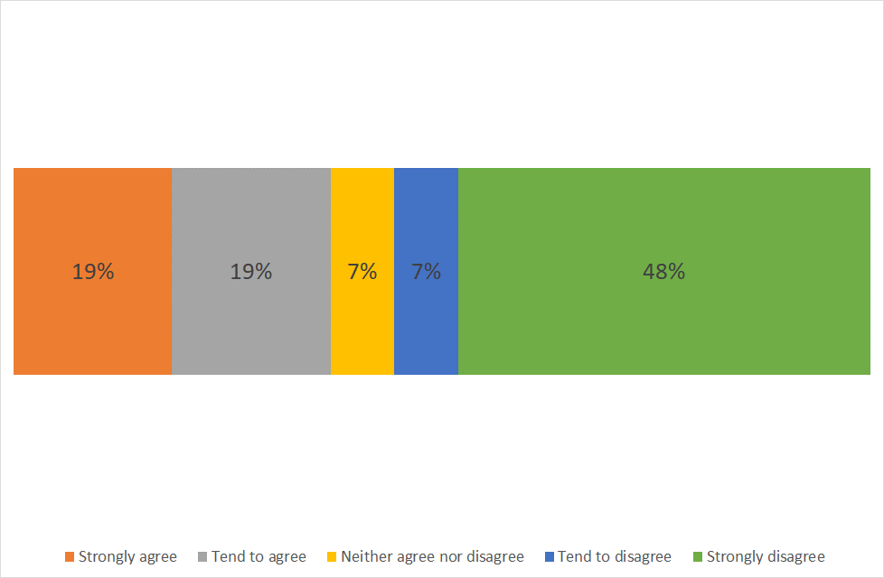

Base: all respondents (27)

To understand why respondents agreed or disagreed with proposal they were asked to provide why 'they say that?'
Due to limited number of responses no analysis or coding of the responses has been carried out.

The verbatim comments are provided below literally as received. They have been grouped by comments from those who agree, those who disagree and those that neither agree or disagree with the proposal.

Comments from respondents who agree with the proposal
- There is a need to manage the cost of the voids. Housing association need to take some of that burden where it’s long term. Most housing associations make a healthy profit, which is reinvested. But the assets of the house is the profit at the end.
- The residents will be severely impacted with a move or having to share their home with someone they have no choice about.
- People with disabilities should feel safe and happy in their homes and have the opportunity to have as full a life as they wish to have, If they are having to pay a rent that covers the cost of missing tenants they will have less income to pay for other things.
- It is not sustainable financially as well as the negative impact on the people living alone and the affect this has on their well-being.
- Hope a review will refresh issues concerning staffing etc.
- we need to maximise the use our existing properties, and fill any vacancies where possible
- I believe Supporting Housing households should be reviewed but wonder if this is being done in conjunction with looking at the pathways and accessibility for potential tenants to the housing forum and being matched to a property that is available. In my personal experience we found for my son a LCC supported living vacancy in Lancaster five months ago that has been empty for at least two years. Social Care still seem unable to find a pathway so that he can be referred to the housing forum in order to be possibly matched with this tenancy. He is fully funded CHC so the funding is unlikely to be a problem. I wonder how many young people may be in a similar position in the county, where they are crying out for a Supported Living …..
- As a provider, providing specialist services, mainly in the Thornton area of Wyre, we are being asked all the time if we have a vacancy. We would like to have the opportunity to create another supported living scheme. Current framework prevent this.
- National organisations e.g. Supportive Housing LLP bought houses in Lancashire for £25.000 and let out on long term agreements via New Foundations to other LD housing providers on long leases at exorbitant rents. They have made over £500,000 profit from a small house in Deepdale. MP Ben Wallace raised the issue with HM Revenue and Customs but they have done nothing. I have used hundreds of £s of my own money fighting this corruption without success. It has been raised with local authorities but no one will do anything.
- As a housing provider it becomes very difficult to allocate properties when there is a blockage from Managing Agents and Commissioners. The communication lines to a commissioner require improvement, and there should be more joint working to allocate or find the right properties for customers. If a managing agent doesn’t pay for the property when it is empty, there is little appetite to proactively find the right person for the property or to let the property. There needs to be a push from commissioners to let the properties to the right people. If the property isn’t deemed suitable: a more detailed response and information is needed as to the reasons why the property isn’t deemed as supported housing.

Comments from respondents who disagree with the proposal
- We are talking about a person's home, if they have lived there a long time moving someone from their surroundings can be very distressing. They should only be moved if they consent to this.
- You could be looking at moving someone out of a long term home at a time in their life when it really isn't appropriate.
- The discussion is around people's homes, where they live and are comfortable. It should never be considered to move them on the basis of under occupancy which is not in their control.
- It is people who are supported not houses. No one should to move houses to sort out financial problems. Why LCC is involved in who lives where is a mystery to me. All they should be responsible for is paying for the accommodation deemed suitable according to their assessed needs and their own choice.
- You are talking about the homes of vulnerable people as a ‘commodity’ and not as a home
- It treats homes as a commodity and supported living as a business, ignoring the fact that it is people and their homes that you are dealing with. It appears to be another form of brutal cost cutting to the most vulnerable in the community.
- Care Act assessments and reviews should already be taking account of the person's living situation and their wishes and preferences. Surely social workers reviewing and providers say they have been reviewing people's needs & supports so why would they not already know if someone needs different housing/may on fact be looking at other housing. This appears to be driven by Lancashire keeping housing voids on a data base no one can access except commissioners. I understand that people then are only give one or two choices by a social worker so no chance to look at whether there may be more suitable options. I also understand that Lancashire took on covering some rent voids of housing if they are vacant for a period …….
- In my view Lancashire should not have taken on underwriting void rents of any properties since they don’t collect any rents on these and the rents collected by a landlord include voids coverage. However, in addition, Lancashire seem to have collected and controlled access to the voids information. Landlords should be responsible for voids lettings – obviously by advertising them in the appropriate area with basic information on the void place property, its approx. geographic area and any co-tenants’ interests and needs including levels of support. Hence LCC should be negotiating withdrawing from any agreements with landlords on rent voids coverage but also ensuring that voids (suitably anonymised) are advertised ……….
- LCC is neither the care provider nor the landlord for these properties. • It is only for assessing the needs of the person receiving support under the Care Act, not for the detailed costing or operational management of the supported housing provision • These housing related issues should not be its concern • However, (foolishly in my view) LCC some years ago accepted responsibility for void rents of some properties. An area over which they have no direct control as they are neither the landlord nor the care provider. • Rents collected by landlords in Supported housing should contain a voids coverage element. Therefore, rather than seeking to save money by moving people who are content and settled where they are ,…..
- I would be pretty angry if the County Council came a reviewed a vacancy in my household.
- People are living happily within their own homes. Many have the capacity to choose how they live. How would you like to be reviewed LCC activity supported and sought out these placements. What next? The old institutions?
- This process is flawed. The voids situation should not be part of LCC's remit. It appears that in the past LCC accepted responsibility for some voids, which they should not have done as LCC is not a landlord or care provider. The voids element should be in in the rental agreement. LCC are responsible for assessing care needs. As many of these have taken place recently by the Re-Modelling Team, LCC should know if different housing is needed. Why should the most vulnerable be made to pay for past mistakes, not of their making, by LCC. I, personally, am very concerned for my LD son who is in supported housing, if a void occurs in his house. As most LD tenants needs are likely to increase as time goes by, due to age and health …..
- The Review should not take place as proposed because: • LCC is neither the care provider nor the landlord for these properties. • LCC is responsible for assessing the needs of the person receiving support under the Care Act, not for the detailed costing or operational management of the supported housing provision • These housing related issues should not be its concern • LCC some years ago accepted responsibility for void rents of some properties which they probably shouldn’t have done as this is an area over which they have no direct control as they are neither the landlord nor the care provider. • Rents collected by landlords in Supported housing should contain a voids coverage element.

Comments from respondents who neither agree or disagree with the proposal

- I suspect the review process is another way to save money for the local authority, whilst not enough time and effort has been taken to explore other options for enabling people to access vacancies in support housing across the county. I neither agree nor disagree due to the individual nature of the question, some reviews for individuals are necessary whilst others aren't depending on their personal circumstance.

Are there any other factors that you feel a review of supported housing households should include?

Respondents were asked to provide anything else they felt the review should include.

Again, due to limited number of responses no analysis or coding of the responses has been carried out.

The verbatim comments are provided below literally as received. They have been grouped by comments from those who agree, those who disagree and those who neither agree or disagree with the proposal.

Comments from respondents who agree with the proposal
- There is clearly a need to have housing which has the flexibility to meet peoples changing needs. Therefore housing needs to be adaptable. More and more people accessing services have more complex needs. The service providers have the skills to provide this but not the correct environments.
- The wishes and needs of the family of person supported should hold as much influence as the corporate voices
- I think it should include the impact living alone has on the person, isolation, contact only with staff, creating dependency as staff take over tasks in an effort to keep busy etc. Contact with other people outside the home. The financial impact and alternative s this money could buy for the person. The area the house is in, is it a community that welcomes and includes the person living there. Dependency of relatives on staff. Effect on staff can override home closures. Influence of staff on choices. Person may not be aware of financial costs or alternatives.
- staffing
- It has been suggested that LCC will look to review supported living vacancies when they have been vacant for 12 months or longer. I think this is too long to wait, a shorter period of time should be considered e.g 6 months or if it is felt there are no prospects of finding someone to share a property due to the existing tenant being unable to share for whatever reason, a solution should be found straight away with no time limit being imposed.
- See previous question
- Providers should be responsible for the property and the voids - this will allow new schemes to be opened instead of continuing in failed placements, saving on time and providing quality services, more person centred. Providers ensure a fair price of rent is agreed with the landlord. MDT approach/BI to be taken around new tenancies - provider to feed in rent cost and the value for money for the service users. Providers share this information with LCC. Independent database for providers to access to advertise their vacancies, services, locality, that social workers and CCG can access in times of change, transition and crisis.
- Concentrate on the LD tenants and not let them became second class citizens or pawns in a power game. Need to remove corruption from the sector. Suspect that Covid 19 may necessitate a delay as organisations are struggling to do the basic support at the moment
- If there are compatibility issues within a scheme, it would be good to complete a review of the service involving all stakeholders. E.g. - there can be one tenant living in a four bedroomed property and there are three empty rooms. As a group we need to look at the possibility of moving that person out and reallocating all four rooms within the property. In Lancashire there is lots of empty supported accommodation because of this issue.

Comments from respondents who disagree with the proposal
- How would a potential move from the current establishment effect the service user and I mean really look at this not just pay lip service to it?
- I understood that housing benefit for people with learning difficulties covered the cost of their rent and there was no shortfall in monetary terms. The tenants have legal rights and should not be moved from one tenancy to another to fill a vacancy.
- The review needs to look at how they can identify housing to meet the choice and needs of the person. In real life people do not move house unless they really want to and they put up with all sorts of inconvenience just because they like where they live . Living in your own community is very important to peoples wellbeing Friends and neighbours who you have known for years are a valuable link in the safeguarding chain. People, especially those who have little understanding are not pawns to be moved around, just to save money. The cost of such a policy may save some money but in lifetime choices or direction it will inevitably cost someone else like the NHS money later on.
- All that matters is the quality of care provided
- Individual needs and circumstances, type of disability or learning difficulty and how this impacts on where they choose to live.
- People's whole situation - ie how long they have been living there; their current activities and access to their neighbourhood; their relationships with co-tenants including how long they have shared; their access to family and friends; access to GPs, dentists, transport, local shops and relations; neighbours, positives about their current accommodation like views, garden, access; would a move mean they can keep their same support provider/ keyworker etc; any change in noise, lifestyle, sleeping habits - this can be complex eg their milkman/window cleaner may need to change - some people manage their getting up by the time their milk man arrives for example! What do we know from their history about how they manage change or stress?
- A person's whole situation would obviously have to be reviewed in a reassessment if Lancashire are proposing a move to them - as opposed to them having capacity and choosing to move outside this proposal. This means looking at what their current tenancy and co-tenants and location offers them in assisting them in their preferred lifestyle, and how they cope with change - ie including their history and knowledge of the person. They should always have an advocate involved who can ensure their legal rights are being observed as well as that they and those who know them well (ie including any family, friends and care agency keyworker) can ensure they are taking account of key things that matter. An advocate under the Care Act can …..
- There are better ways to resolve this issue: 1. Renegotiate with landlords over void rent responsibility (as above) 2. Ensure landlords advertise all voids vacancies as widely as possible* * These should be advertised by the Landlord (not LCC) just as with other housing BUT with a note that they are only available for suitably qualified tenants (i.e. people with LD) and with a suitably anonymised note about the co-tenants interests and levels of support. If necessary the specific address does not need to be included simply a reference to the local area (Plunignigton/ New Hall Lane, Cadley etc.) This would overcome any GDPR concerns which in my view are spurious. Surely tenants in a house with voids can be asked by the landlord
- What business is it of the County Council to review a household
- Voids. Open up the voids market and share with care providers
- All tenants should be told in WRITING that they can have access to an independent advocate (such as Advocacy Focus or another organisation) who could renegotiate with Landlords about the voids. Unfortunately, it appears that there is very limited access to the database of properties. Landlords need to be able to advertise their properties more widely stating that the property is only suitable for LD tenants, no personal information needs to be given, just other tenants needs, care support, interests. This would comply with GDPR rules. This would give prospective tenants more choice, and would maybe reduce voids. The tenants may not know their rights and not all have family or friends to help them, and may feel they have to do what….
- There are better ways to resolve this issue: 1. LCC renegotiate with landlords over void rent responsibility (as above) 2. The voids situation is now hard to resolve because Lancashire seems to have collected and controlled access to the voids information on a data base no one can access except commissioners. 3. Ensure landlords advertise all voids vacancies as widely as possible* *These should be advertised by the Landlord (not LCC) just as with other housing BUT with a note that they are only available for suitably qualified tenants (i.e. people with LD) and with a suitably anonymised note about the co-tenants interests and levels of support. If necessary the specific address does not need to be included simply a reference to it.

Comments from respondents who neither agree or disagree with the proposal

- Staff moral and pay. As we are told on a near daily basis, it's not about us, it's about the service users, we as staff feel we are doing jobs that some people need university degrees for. We know for fact that we get paid less than we should for sleep shifts and if we are disturbed during the night, not by an emergency, but by drunken service users shouting for hours on end, we should not be expected to A. Dispense medication for that morning, and B. Should not be expected to work a full 8-9 hr shift with very little or no sleep. I would rather loose the £51.50 per week for my sleep shift to have a good nights sleep at home!!!!!!!!!!!!!!
- What other options can be explored to prevent under occupancy. Has the property been advertised properly and through suitable channels (housing bidding sites). What will a potential change of accommodation have on the person being reviewed? Locality of activities, known and used activities and travel changes Contact with friends/family Contact with a known wider community Change of area and impact on the sensory needs of the individual Change of environment Appropriate matching/compatibility of proposed tenants

3.2 People who completed the survey

- Are you completing the survey as…….?

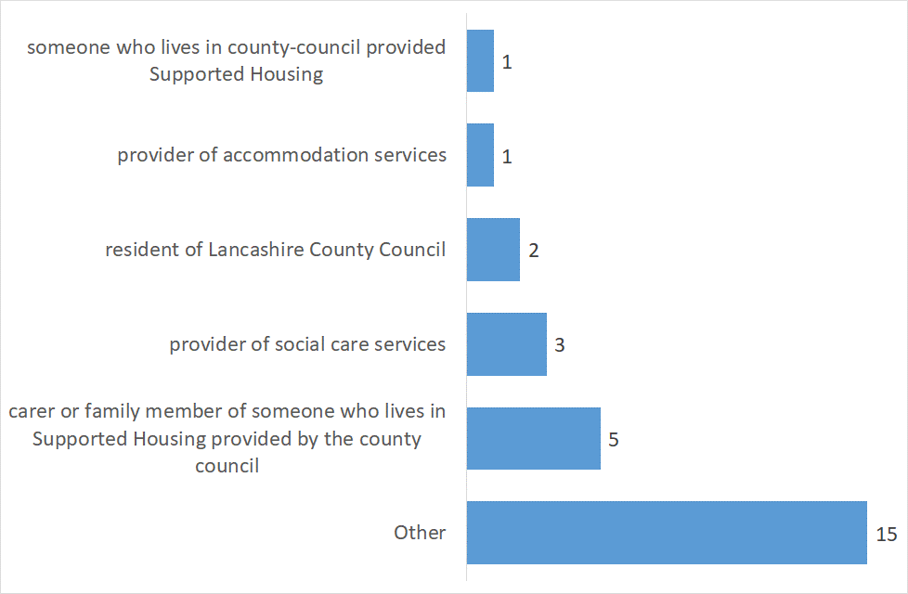
Base: all respondents (27)

Those who ticked other provided following:
- Support worker
- Leaving Care Worker
- Parent of potential service user.
- Member of public retired SW.
- Relative of someone with learning difficulties who has used supported living services previously.
- Advocacy Service
- I was a parent and my son died some years ago now. However I am still actively involved in the LD world
- Parent
- LCC employee
- a volunteer supporting people to meet; an ex-provider of support services; a registered social worker
- Parent Carer of potential Supported housing Tenant
- volunteer who also is a member of the public & has been involved in care support services
- Independent Advocate for Preston & District Learning Disability Forum
- Citizen of Lancashire
- Preston & District L.Disability Forum including people with ld;families,carers,providers,advocates

Appendix 1 – respondent profile

- Are you…?
 | %
Female | 69%
Male | 15%
Prefer not to say | 15%
Base: all respondents (26)

- What is your age?
 | %
Under 25 | 7%
45-60 | 41%
Over 60 | 41%
Prefer not to say | 11%
Base: all respondents (27)

- Do you have a disability?

 | %
Yes | 7%
No | 78%
Prefer not to say | 15%
Base: all respondents (27)

